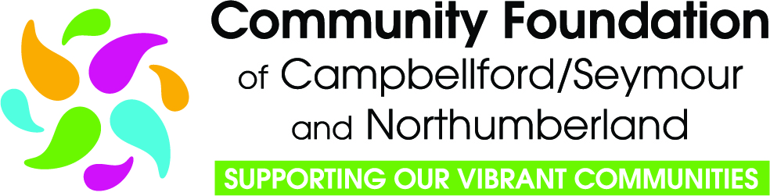

Job Opportunity For Youth
Grant Program

2026 Applicant Guide

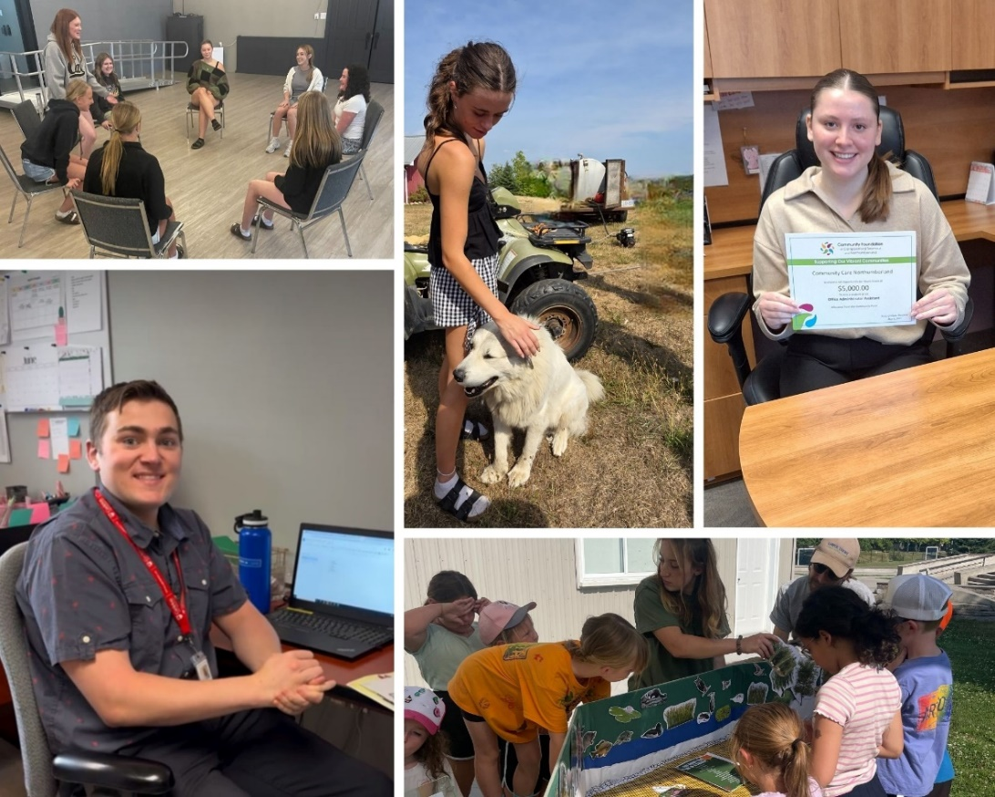
Contents
1. Overview of Job Opportunity for Youth (JOY) Grant Program 3
2. Changes to Grant Program 3
3. About the Community Foundation of Campbellford/Seymour and Northumberland 4
4. Who Can Apply 4
5. Information For a Non-Charity or Non-Qualified Donee 5
6. Geographic Catchment Area 5
7. Alignment with the Northumberland’s Vital Signs Report 5
8. Funding Requests and Conditions 6
9. Youth Eligibility Criteria 6
10. Program Guidelines 7
11. How to Apply 7
11.1 Step 1 - Organization Profile Form 7
11.2 Step 2 - Grant Program Request Form 8
11.3 Step 3 - Grant Application 8
12. Grant Criteria & Evaluation 8
13. Notification of Decision 9
14. Requirements of Grantees 9
15. Payment Schedule 9
16. Recognition Guidelines 9
16.1 Communications Embargo 10
16.2 Other Required Recognition 10
16.3 Recognition After Grant Completion 10
17. Reporting 11
17.1 Interim Report – A Check-In 11
17.2 Troubleshooting 11
17.3 Final Report – Impact and Accountability 11
17.3.1 Storytelling 11
17.3.2 A picture is worth 1000 words 12
17.3.3 Tips for Writing Grant Reports 12
18. Application Assistance 12

- Overview of Job Opportunity for Youth (JOY) Grant Program
Thank you for your interest in applying to the Community Foundation of Campbellford/Seymour and Northumberland’s Job Opportunity for Youth Grant program.

The Job Opportunity for Youth grant initiative was developed in 2012 to address the specific community need of youth employment. It aims to support charitable and non-profit organizations in providing summer employment for youth, and to offer a meaningful work experience while introducing youth to careers in the non-profit sector.

We expect that the initiative will achieve some or all of the following goals:
- Provide quality work experience for youth;
- Provide opportunities for youth to develop and improve their skills to assist with future employability;
- Engage youth through meaningful participation and sustained involvement;
- Provide opportunities for youth to build connections with other employers;
- Provide organizations an opportunity to share knowledge through supervising and mentoring a youth.

- Changes to Grant Program
The Community Foundation will be celebrating its 25th Anniversary in 2026 and we are looking forward to continuing to support community service organizations in their important community work. Since our inception in 2001, we have distributed over $5 Million for projects and programs that have enhanced the quality of life for the residents of our community. View Past Grants

Starting with the 2026 grant cycle, we have made a number of changes to our grant program. Details about each change are outlined in this guide:
- We took advantage of the Government of Canada’s legislative change in 2025, that recognizes the significant value that non-qualified donees bring to charitable work. In order to comply with the new regulations, we amended our community foundation’s charitable purposes, which will allow us to grant to non-qualified donees directly without the need for a charitable partner. (See item 4)
- We have invested in a new cloud-based software suite with Zoho Corporation, which will provide a higher level of cyber security, and incorporates an online grant management system to help increase our efficiency and capacity to manage various grant programs.
- New applicants are required to complete an Organization Profile Form, as a first step in the application process. (See Item 11)
- Recognition Guidelines have been updated. (See Item 16)

- About the Community Foundation of Campbellford/Seymour and Northumberland

Our Mission - Champion the gifts of energy, ideas and money to enhance meaningful and lasting impacts through grants, stewardship, leadership and partnership that benefit our community.
Our Vision - A strong, healthy, connected, inclusive and caring community.
Our Values:
- Operating in an open and transparent manner
- Being responsive to community needs
- Participating actively in community partnerships
- Reflecting and respecting the diversity in our community
- Encouraging innovation
- Balancing short-term and long-term goals
- Adhering to the standards of professional and ethical practices for charities

- Who Can Apply
In order to be eligible to apply for a grant, an organization must:
- Be a qualified donee registered with Canada Revenue Agency (registered charities, municipal governments, indigenous governing body, etc.); or
- Be a not-for-profit organization registered under the Canada Not-for-profit Corporations Act; or
- Be a cooperative registered with Corporations Canada under the Canada Cooperatives Act; or
- Be a community service group or association that has been in existence for more than one year and can demonstrate a capacity to manage and execute projects and/or programs that have a charitable purpose.

Organizations must also:
- Make services available without discrimination;
- Agree to abide by the Community Foundation's Recognition Policy;
- Be in good standing with regards to the Grant Terms and Condition for previous grants.

Ineligible Applicants:
- An applicant organization may not include, as part of its senior administration, a Community Foundation of Campbellford/Seymour and Northumberland (CFCSN) employee or their immediate family.
- Members volunteering on the Grants Committee, who also volunteer with an applicant organization, are recused from reviewing, scoring, and commenting on those applications, and may not discuss the applications with other committee members.
- Information For a Non-Charity or Non-Qualified Donee
NEW - Starting with the 2026 grant cycle!

A non-charity (non-qualified donee), such as a registered not-for-profit organization, a cooperative, or well-established community group or association may now apply directly to the community foundation for funding.

Grant funding can only be used for charitable activities that further the community foundation's charitable purposes. The Job Opportunity for Youth program’s charitable purposes fall under the category of Advancement of Education and Youth, and aligns with these examples - specific career or job skills training, on-the-job training, and practical business training and experience.

To find out more about current CRA guidelines, please read Guidance CG-032.

- Geographic Catchment Area
The JOY Grant is available to community service organizations servicing Northumberland County.
JOY grant funding will be disbursed from the Northumberland County Fund to organizations serving:
- Alderville First Nation
- Alnwick/Haldimand Township
- Hamilton Township
- Municipality of Brighton
- Municipality of Port Hope
- Town of Cobourg
- Township of Cramahe
JOY grant funding will be disbursed from the Campbellford/Seymour Community Fund to organizations serving:
- Municipality of Trent Hills

- Alignment with the Northumberland’s Vital Signs Report
Vital Signs is the largest community-driven data program in Canada. It allows community organizations to make data-driven decisions that respond to what communities need.

Community foundations use the knowledge gained through Vital Signs to lead on impact in their community. Priorities identified by Vital Signs are often incorporated into the strategic direction of the foundation and guide decision-making as a community leader and funder. As a result, community foundations are able to move the needle on the most pressing issues.

The Job Opportunity for Youth grant program aligns with the theme area of Decent Work and Livable Income in our Northumberland’s Vital Signs Report. Sustainable economic growth requires societies to create conditions that allow people to have quality jobs. Youth unemployment in Canada has recently reached a nine-year record high, with Ontario experiencing some of the country’s highest youth unemployment rates.

- Funding Requests and Conditions
Grant Maximum is $5,000.00

Funding Conditions:
- Only one application per organization will be accepted for the 2026 grant cycle.
- The Community Foundation reserves the right to provide full or partial funding.
- There is no pre-determined number of projects to be funded, but there is a pre-determined amount of funding available to be disbursed.
- The Community Foundation prefers not to be the only monetary funder. Applications showing other sources of funding, including contributions from the organization itself, may be considered in the review process.
- Organizations cannot apply for a grant unless they are in good standing with their previous year’s grant.
- Grant funding is paid in two installments. An interim report will be required half-way through the placement and must be submitted before the second installment is released.

- Youth Eligibility Criteria
- Applicants are between the ages of 15 to 29 on the first day of employment.
- Applicants ideally should be residents of the organization’s local community.
- Applicants must have a valid Social Insurance Number and be legally entitled to work in Canada.
- Applicant is not currently employed in the JOY position being offered.
- Applicant must not have been employed in a position through this grant initiative in previous years. Before hiring, contact the Community Foundation office (admin@cfcsn.ca or 705-653-2005) with name of the prospective employee to check their eligibility.
- Applicant cannot be self-employed as the employer must establish an employer-employee relationship with the youth participant.
- Applicant cannot be an Immediate Family Member of an employee, board member or director of the organization.

- Program Guidelines
- Salary is to be based on minimum wage ‐ $16.60 per hour for students under the age of 18 (less than 28 hrs./week) and $17.60 per hour for general workers (As of October 1, 2025).
- We encourage your organization to consider compensation that is above the minimum wage if possible.
- Employers are required by law to meet all CRA reporting requirements by remitting source deductions. See CRA website for more information. Grant funding cannot be used for source deductions.
- Employment can be from 4 to 16 weeks in duration, must be a minimum of 20 hours and a maximum of 40 hours per week, and must take place between April 1 and August 31.
- The job opportunity can be either project based (i.e. Development of a Marketing Plan), or a designated position (i.e. Administrative Assistant).
- Organizations must indicate their capacity to commit to a work and learning plan to maximize training, job skill development and hands‐on experience for the employee.
- Organization must provide the participant with all the information concerning health and safety standards and regulations regarding their work environment and, if necessary, provide training, information and safety equipment required to accomplish their tasks.
- Organization must ensure that the job opportunity is carried out in a safe, inclusive and healthy environment.
- Participants will be required to provide an “experience story” at the end of the employment term as part of the final Impact & Accountability Report.

- How to Apply
This year, our grant program is administered as a three-stage process through the online Zoho platform.

  - Step 1 - Organization Profile Form
New applicants must complete an Organization Profile Form as a first step in the application process. On the Apply for a Grant page on our website, go to the Information for New Applicants drop-down, and click on the link for the Organization Profile Form.

This form is a due diligence review to consider the organization’s purpose, mission, staff & volunteers, history, reputation, and other governance questions to assess risk level.

Online form should be completed and submitted by December 15th at the latest to ensure it can be reviewed and a determination made by the Community Foundation regarding eligibility.
Before completing the form, ensure you have the following documents scanned and ready to upload to the form:
- List of Board of Directors
- Most recent approved budget
- Latest audited or reviewed financial statements
- Latest Annual Report (if one is produced)

  - Step 2 - Grant Program Request Form
New Applicants - Once your Organization Profile Form has been reviewed and your organization has been deemed eligible to apply, you will be invited to the application stage. You will receive a Grant Program Request Form by email. Choose the Job Opportunity for Youth Grant Application, enter you’re the email address you entered on the Organization Profile Form, and submit the form. The application form will automatically be sent to you, and is linked to your organization’s contact information in the Zoho platform.

Previous Applicants – On the Apply for a Grant page on our website, go to the Information for Previous Applicants drop-down, and click on the link for the Grant Applicant Request Form. Choose the Job Opportunity for Youth Grant Application, enter your email address, and submit the form. Please use the email address registered with us (the email address used for previous applications), or call us to check which email address we have attached to your organization’s record). The application form will automatically be sent to you, and is linked to your organization’s contact information in the Zoho platform.

  - Step 3 - Grant Application
Once your Grant Program Request Form has been submitted, you will receive an email with a link to the online grant application form. Again, the application form is automatically linked to your organization in our Zoho platform.
- Annual deadline is January 15th.
- Please ensure you have the Budget & Project Funding Spreadsheet completed, and have two quotes for each budget item over $250, scanned and ready to upload to your application. These cannot be uploaded separately after the application has been submitted.
- Any submission made after the deadline date will be deemed ineligible. No other documentation will be accepted after the deadline, unless it is provided in response to a CFCSN inquiry.

Please note:
- Convey your proposal in your own words.
- Clarity and conciseness are key – less is more. Most fields are a maximum of 200 words.
- Plain language is preferred rather than acronyms.

- Grant Criteria & Evaluation
Applications are reviewed and scored by our Grants Committee, which is made up of community volunteers, and can include members of our Board of Directors.

When considering applications for funding, our Grants Committee considers applicants that:
- Demonstrate a capacity to take on the role of supporting and mentoring a youth participant;
- Commit to providing the youth participant with meaningful, hands-on work experience;
- Commit to teaching the youth participant career-readiness skills.

- Notification of Decision
By March 30th, applicants will be notified through the Zoho platform, if their application has been approved or denied, and if approved for funding, what the next steps will be.

- Requirements of Grantees
Applicants approved for funding will be required to:
- Review, sign and submit a Letter of Agreement confirming that they will abide by the Grant Terms and Conditions;
- Attend the Community Foundation’s Annual General Meeting and Grant Announcement Event which is generally held in May;
- Submit Interim Reports and Final Reports in a timely manner; and,
- Abide by the Community Foundation’s recognition guidelines (See 16 below).

- Payment Schedule
Grant payments will be scheduled in two installments, based on the job start date specified in the application, with an interim report required between payments.

No grant funding will be forwarded until after our Annual General Meeting and Grant Announcement Event is held in May.

- Recognition Guidelines
Recognition of the grants provided by the Community Foundation helps to increase our profile in the community. Please help us make sure that we all benefit from the increased awareness of the excellent work we all do to enrich our community.

Recognition also helps maintain the highest standards of public accountability and to ensure transparency regarding the distribution of public funds.

In compliance with our Grant Recognition Policy and your Letter of Agreement, your organization is required to publicly recognize the Community Foundation of Campbellford/Seymour and Northumberland.
  - Communications Embargo
Organizations must observe a communications embargo period. This period starts once you have been informed of your grant and continues until after a public announcement is made by the Community Foundation at its Annual General Meeting and Grant Announcement Event, generally held in early May.

During the communications embargo period, you must not make any public or media announcements about your grant, which includes not posting news on social media or issuing a media release. Job Opportunity for Youth grantees may advertise for the position, but should not mention the grant funding.

  - Other Required Recognition
While your grant is active, your organization is required to:
- Display the grant certificate presented at our AGM and Grant Announcement Event in a public location for the duration of the grant project.
- Include the CFCSN logo in the following relevant places:
  - Your organization’s website
  - Grant-related materials such as brochures, program guides, videos and other communication products
Do not include the CFCSN logo on your organization’s letterhead, in your email signature, business cards or job ads.
Link to CFCSN’s Media Centre to download Logos
- Approved wording – Please use the text “Supported by a grant from the Community Foundation of Campbellford/Seymour and Northumberland” in written reports, press releases, or verbal presentations, or other communications where using our logo isn’t appropriate.
- Acknowledge CFCSN funding in the following communication materials and/or activities regarding your grant project or program:
  - Media interviews
  - Events (Invitation sent to CFCSN would be appreciated)
  - Newsletter and Annual reports
  - Online videos
  - Promotional materials, both online and in print
  - Social media activities
If using social media, tag CFCSN @CFCampbellfordSeymourNorthumberland

  - Recognition After Grant Completion
A grant is considered closed 90 days after submission of the Impact & Accountability Report. Once a grant is closed, public acknowledgments of the Community Foundation can be removed or taken down.

You may choose to continue to acknowledge the Community Foundation after your grant is closed to help increase awareness of the excellent work we all do to enrich our community.

- Reporting
Through your feedback, we learn more about the various aspects that contribute to project success. This in turn helps our organization achieve our goal of community building. The information you share will benefit our grants program by helping us to understand and communicate the impact of your grant on our community, and to capture lessons learned to make our grant program more effective.

Reporting requirements will be scheduled in the Zoho platform and links to online report forms will be emailed to organizations automatically as per the schedule.

  - Interim Report – A Check-In
Interim reports are required to be submitted before the second installment of funding is forwarded. The purpose of this report is to ensure that the experience is meeting the expectations of both the youth and the organization.

  - Troubleshooting
Sometimes we set out with the best of intentions and run into challenges along the way. If you encounter a roadblock or need to pivot, we shouldn’t be hearing about a major problem for the first time in a grant report. Reach out to a Community Foundation staff member by phone or email so that we can assist you and talk about an alternative solution as soon as possible. We want to honour the original intentions of the grant as much as we can, and alternative plans need to be approved by the Community Foundation if there is a significant change from the original purpose.

We also understand that budgets may shift, and this is acceptable as long as the funding stays true to the grant’s original purpose or intention. If you need to entirely pivot, then you must receive permission from the Community Foundation to do so.

  - Final Report – Impact and Accountability
An Impact and Accountability Report is required for all grants and is based on a storytelling format. The purpose of the Impact and Accountability Report is to ensure accountability for, and appropriate use of, entrusted funds; to report on the impact of the grant; and to learn from the experience.

A Media Release Form for both the Organization and the Individual must be completed and submitted. This form will be forwarded automatically through the Zoho platform.

    - Storytelling
Two stories are required to be submitted – one from the organization’s perspective, and one from the youth participant about their experience.

We may use your stories for internal reporting and/or for sharing through social media, newsletters, and on our website. We may edit any text that is sent to us so that we can communicate the text appropriately to the platform.

Story Guidelines:
- You can include an event, a milestone, or something you think is valuable to share.
- What were your project goals and to what extent did you meet them? Were there any unintended results or additional outcomes?
- What lessons were learned? What went well, what did not go so well? What would you do differently? Is there something you could have done to have a broader impact?
- Numbers of individuals reached by your project, project partners, community involvement, number of staff and/or volunteers involved, and what they contributed.

    - A picture is worth 1000 words
Photos and/or videos from the project, event or youth placement, are welcomed, as these will be used alongside your stories. Please provide high-resolution images that are print quality, minimum 300 dpi. Photo or Video credit is required.

Recipients who do not submit an Impact & Accountability Report for their grant cannot apply for future funding from the Community Foundation. Organizations must be in good standing with the previous years’ grants before applying for another grant.

    - Tips for Writing Grant Reports
- Track everything from the start – data, stats, metrics, etc.
- Pay attention to your goals – original goals in application.
- Take photos as you go – helpful for storytelling and showing impact.
- Focus on the outcomes – share how your work made a difference.

- Application Assistance
We are here to support you! We encourage you to reach out at any time with questions and we also love receiving informal updates about how things are going. We thank you for all the work that you do in the community.

Please feel free to contact our office during regular office hours if you have questions or require technical assistance at any point during the application process.

Office Phone: 705-653-2005
Martha Murphy, CEO – info@cfcsn.ca Mobile: 705-653-6766
Pamela Van De Steeg, Executive Assistant – admin@cfcsn.ca

Front Cover Photos – 2025 Job Opportunity for Youth Grants
Artworth Art Camp, IncrEdible Trent Hills, Community Care Northumberland, Campbellford Memorial Hospital Foundation, Artworth Art Camp.

