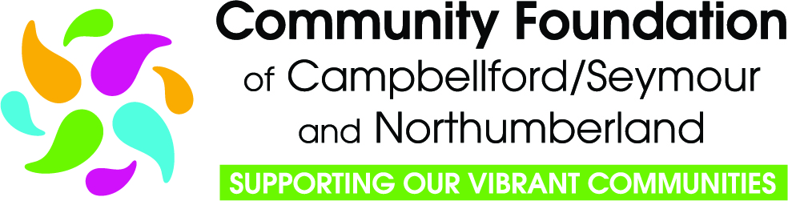

Community Impact Grant &
Mini Grant Programs
2026 Applicant Guide
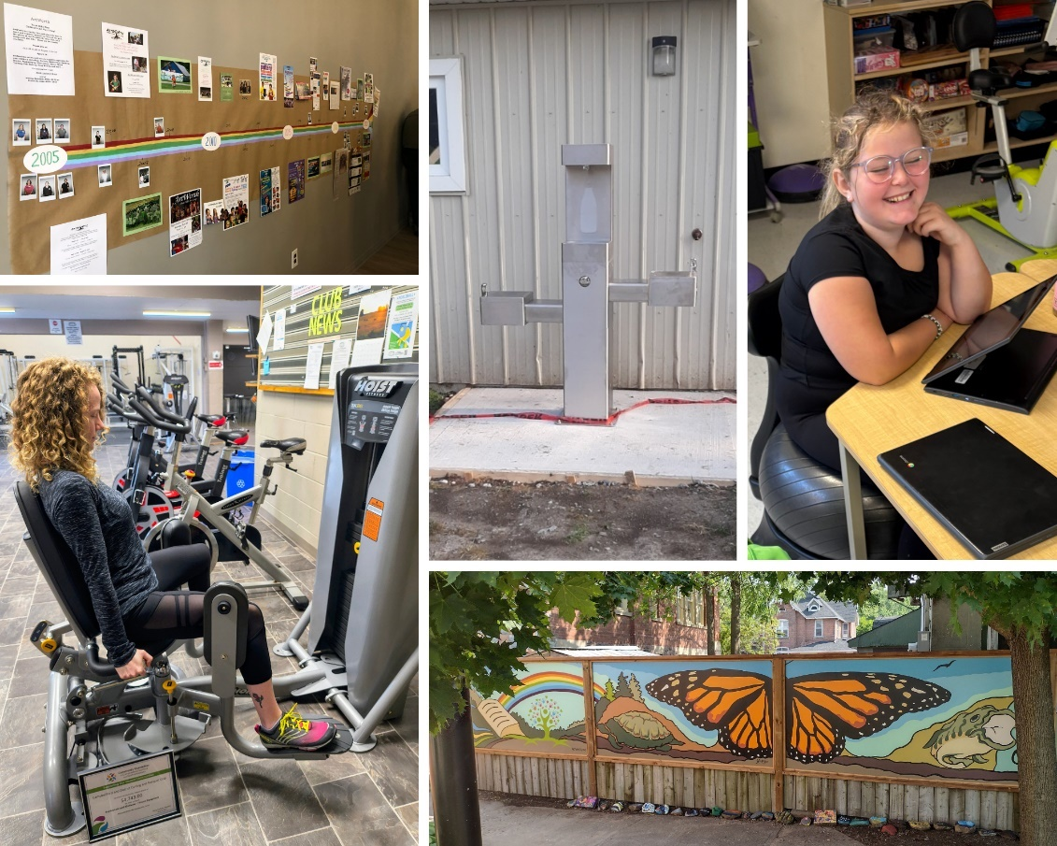

Contents
1. Overview……. 3
3. Who Can Apply 4
4. Information For a Non-Charity or Non-Qualified Donee 4
5. Geographic Catchment Area 5
6. Alignment with the Northumberland’s Vital Signs Report 5
7. Funding Requests 5
8. Ineligible Expenditures 6
9. How to Apply 7
9.1 Step 1 - Organization Profile Form 7
9.2 Step 2 - Grant Program Request Form 7
9.3 Step 3 - Grant Application 7
10. Grant Criteria & Evaluation 8
11. Notification of Decision 8
12. Requirements of Grantees 9
13. Payment Schedule 9
14. Recognition Guidelines 9
14.1 Communications Embargo 9
14.2 Other Required Recognition 10
14.3 Recognition After Grant Completion 10
15. Reporting…….. 10
15.1 Interim Report – A Check-In 11
15.2 Troubleshooting 11
15.3 Final Report – Impact and Accountability 11
15.3.1 Storytelling 11
15.3.2 A picture is worth 1000 words 12
15.3.3 Tips for Writing Grant Reports 12
16. Application Assistance 12

- Overview
Thank you for your interest in applying to the Community Foundation of Campbellford/Seymour and Northumberland’s grant program.

The Community Foundation will be celebrating its 25th Anniversary in 2026 and we are looking forward to continuing to support community service organizations in their important community work. Since our inception in 2001, we have distributed over $5 Million for projects and programs that have enhanced the quality of life for the residents of our community. View Past Grants.

Starting with the 2026 grant cycle, we have made a number of changes to our grant program. Details about each change are outlined in this guide:
- We took advantage of the Government of Canada’s legislative change in 2025, that recognizes the significant value that non-qualified donees bring to charitable work. In order to comply with the new regulations, we amended our community foundation’s charitable purposes, which will allow us to grant to non-qualified donees directly without the need for a charitable partner. Proposals must show how the project/program furthers our charitable purposes. (See item 4)
- Our applications are now aligned with our Northumberland’s Vital Signs Report and contain questions regarding how your project or program addresses one or more of the key indicators. (See Item 6)
- In celebration of our 25th anniversary, the amount available for mini grants has been increased to $2,500. (See item 7)
- We have invested in a new cloud-based software suite with Zoho Corporation, which will provide a higher level of cyber security, and incorporates an online grant management system to help increase our efficiency and capacity to manage various grant programs.
- New applicants are required to complete an Organization Profile Form, as a first step in the application process. (See Item 9)
- Recognition Guidelines have been updated. (See Item 14)

- About the Community Foundation of Campbellford/Seymour and Northumberland

Our Mission - Champion the gifts of energy, ideas and money to enhance meaningful and lasting impacts through grants, stewardship, leadership and partnership that benefit our community.
Our Vision - A strong, healthy, connected, inclusive and caring community.
Our Values:
- Operating in an open and transparent manner
- Being responsive to community needs
- Participating actively in community partnerships
- Reflecting and respecting the diversity in our community
- Encouraging innovation
- Balancing short-term and long-term goals
- Adhering to the standards of professional and ethical practices for charities

- Who Can Apply
In order to be eligible to apply for a grant, an organization must:
- Be a qualified donee registered with Canada Revenue Agency (registered charities, municipal governments, indigenous governing body, etc.); or
- Be a not-for-profit organization registered under the Canada Not-for-profit Corporations Act; or
- Be a cooperative registered with Corporations Canada under the Canada Cooperatives Act; or
- Be a community service group or association that has been in existence for more than one year and can demonstrate a capacity to manage and execute projects and/or programs that have a charitable purpose.

Organizations must also:
- Make services available without discrimination;
- Agree to abide by the Community Foundation's Recognition Guidelines;
- Be in good standing with regards to the Grant Terms and Condition for previous grants.

Ineligible Applicants:
- An applicant organization may not include, as part of its senior administration, a Community Foundation of Campbellford/Seymour and Northumberland (CFCSN) employee and their immediate family
- Members volunteering on the Grants Committee, who also volunteer with an applicant organization, are recused from reviewing, scoring, and commenting on those applications, and may not discuss the applications with other committee members.

- Information For a Non-Charity or Non-Qualified Donee
NEW - Starting with the 2026 grant cycle!

A non-charity (non-qualified donee), such as a registered not-for-profit organization, a cooperative, or well-established community group or association may now apply directly to the community foundation for funding.

Grant funding can only be used for charitable activities that further the community foundation's charitable purposes. There is a mandatory question on the grant application asking how the proposed project or program furthers our charitable purposes.

To find out more about current CRA guidelines, please read Guidance CG-032.

- Geographic Catchment Area
Grants are available to community organization providing services in Campbellford/ Seymour.
- Community Impact Grant funding will be disbursed from the Campbellford/Seymour Community Fund.
- 25th Anniversary Mini Grant will be disbursed from Funds established to support specific causes – Environment, Arts & Culture, Children & Youth in Recreation, Social Services.

Organizations operating outside of Campbellford/Seymour may apply, as long as the project or program is to the benefit of the residents of Campbellford/Seymour.

- Alignment with the Northumberland’s Vital Signs Report
Vital Signs is the largest community-driven data program in Canada. It allows community organizations to make data-driven decisions that respond to what communities need.

Community foundations use the knowledge gained through Vital Signs to lead on impact in their community. Priorities identified by Vital Signs are often incorporated into the strategic direction of the foundation and guide decision-making as a community leader and funder. As a result, community foundations are able to move the needle on the most pressing issues.

A question in the Community Impact Grant application asks which theme area and key indicator the project or program addresses, and how. This question will be considered as part of the review process, but the proposal will not be eliminated if the project or program does not address one of the pressing issues outlined in the report.

- Funding Requests
Community Impact Grants - funding is capped at $5,000.00 per proposal, due to our commitment to the Municipality of Trent Hills for the new Recreation and Wellness Centre in Campbellford, part of the recreation re-development initiative of Flourish ~ The Trent Hills Wellness Campaign.

25th Anniversary Mini Grants – We have $2,500 from our established funds supporting these specific causes - Environment, Arts & Culture, Children & Youth in Recreation, Social Services - to distribute in 2026.

Please note:
- Only one application per organization will be accepted for the 2026 grant cycle.
- The Community Foundation reserves the right to provide full or partial funding.
- There is no pre-determined number of projects to be funded, but there is a pre-determined amount of funding available to be disbursed.
- The Community Foundation prefers not to be the only monetary funder. Applications showing other sources of funding, including contributions from the organization itself, will be considered during the review process.
- Organizations cannot apply for a grant unless they are in good standing with their previous year’s grant.
- Do not "bundle" multiple projects on one application form.
- Organizations can apply for a second cycle of funding for a program that was funded in a previous year, provided there is evidence the program is developing successfully, or to enhance or extend the project or program.

- Ineligible Expenditures
The Community Foundation will consider supporting reasonable and essential expenditures required to implement the proposal.
Applications will not be considered:
- To support core operating costs (including wages, salaries, remuneration, stipends or like payments, except for the Job Opportunity for Youth Grant program).
- To support operating costs or core services which are directly or indirectly publicly funded, such as municipalities, hospitals, and school boards.
- To support existing and core programs and services (expanding a successful program or service may be considered).
- To cover deficits or to retire debts.
- To support capital building campaigns, predictable repairs or replacements to buildings or predictable repairs or replacement of equipment. (Requests for appliances may be considered but are not a funding priority).
- For fundraising activities or campaigns.
- To fund activities that serve primarily the membership, or purposes of religious or political organizations.
- From individuals, or for individuals (including subsidies, sabbatical leaves, conferences, or student exchanges).
- For sponsorships, such as supporting an event, activity, person or organization financially.
- To increase endowment funds or annual drives for sustaining support.
- For similar projects or programs more than 3 times for a single organization.
- To fund tours or travel.
- For advocacy initiatives (activities by an individual or group that aims to influence decisions within political, economic and social institutions).
- For expenses incurred prior to the community foundation awarding the grant.
- For organizations that have not completed the terms of any previous grant(s) or have not submitted reports due for those previous grants.

- How to Apply
This year, our grant program is administered as a three-stage process through the Zoho platform.

  - Step 1 - Organization Profile Form
New applicants must complete an Organization Profile Form as a first step in the application process. On the Apply for a Grant page on our website, go to the Information for New Applicants drop-down, and click on the link for the Organization Profile Form.

This form is a due diligence review to consider the organization’s purpose, mission, staff & volunteers, history, reputation, and other governance questions to assess risk level.
Online form should be completed and submitted by December 15th at the latest to ensure it can be reviewed and a determination made by the Community Foundation regarding eligibility. Before completing the form, ensure you have the following documents scanned and ready to upload to the form:
- List of Board of Directors
- Most recent approved budget
- Latest audited or reviewed financial statements
- Latest Annual Report (if one is produced)

  - Step 2 - Grant Program Request Form
New Applicants - Once your Organization Profile Form has been reviewed and your organization has been deemed eligible to apply, you will be invited to the application stage. You will receive a Grant Program Request Form by email. Choose one grant program, enter the email address you entered on the Organization Profile Form, and submit the form. The application form will automatically be sent to you, and is linked to your organization’s contact information in the Zoho platform.

Previous Applicants – On the Apply for a Grant page on our website, go to the Information for Previous Applicants drop-down, and click on the link for the Grant Applicant Request Form. Choose one grant program, enter your email address, and submit the form. Please use the email address registered with us (the email address used for previous applications), or call us to check which email address we have attached to your organization’s record). The application form will automatically be sent to you, and is linked to your organization’s contact information in the Zoho platform.

  - Step 3 - Grant Application
Once your Grant Program Request Form has been submitted, you will receive an email with a link to the online grant application form for the grant program you requested. Again, the application form is automatically linked to your organization in our Zoho platform.
- Annual deadline is January 15th.
- Please ensure you have the Budget & Project Funding Spreadsheet completed, two quotes for each budget item valued over $250, and Letters of Support (if applicable), scanned and ready to upload to your application. These cannot be uploaded separately after the application has been submitted.
- Any submission made after the deadline date will be deemed ineligible. No other documentation will be accepted after the deadline, unless it is provided in response to a CFCSN inquiry.

Please note:
- Convey your proposal in your own words.
- Clarity and conciseness are key – less is more. Most fields are a maximum of 200 words.
- Plain language is preferred rather than acronyms, technical or professional terminology.
- Citations for data/statistics are not required, but if desired, they can be uploaded as a separate document to the application form.
- Ensure your project or program is “doable”.
- Consider the concept of “nothing about us, without us” regarding community and end-user involvement in the proposal.

- Grant Criteria & Evaluation
Applications are reviewed and scored by our Grants Committee, which is made up of community volunteers, and can include members of our Board of Directors.

When considering applications for funding, our grant review committee considers projects or programs that:
- Address challenges and opportunities outlined in our Northumberland's Vital Signs report
- Impact people in a significant way or means
- Build effective community partnerships
- Improve organizational effectiveness
- Plan for continuation of the project beyond initial funding
- Realize a significant and sustainable result with a moderate amount of funding
- Are new and innovative, or are enhancing or extending an existing or previously funded project

- Notification of Decision
By March 30th, applicants will be notified through the Zoho platform, if their application has been approved or denied, and if approved for funding, what the next steps will be.

- Requirements of Grantees
Applicants approved for funding will be required to:
- Review, sign and submit a Letter of Agreement confirming that they will abide by the Grant Terms and Conditions;
- Attend the Community Foundation’s Annual General Meeting and Grant Announcement Event which is generally held in May;
- Submit Interim Reports (if applicable) and Final Reports in a timely manner; and,
- Abide by the Community Foundation’s Recognition Guidelines (see 14 below).

- Payment Schedule
Grant payments may be scheduled based on the project/program start date specified in the application, and are usually paid in one installment up-front. Payments may be scheduled in two installments depending on the type of project or if the organization is a first-time grantee.

No grant funding will be forwarded until after our Annual General Meeting and Grant Announcement Event, which is usually held in early May.

- Recognition Guidelines
Recognition of the grants provided by the Community Foundation helps to increase our profile in the community. Please help us make sure that we all benefit from the increased awareness of the excellent work we all do to enrich our community.

Recognition also helps maintain the highest standards of public accountability and to ensure transparency regarding the distribution of public funds.

In compliance with our Grant Recognition Policy and your Letter of Agreement, your organization is required to publicly recognize the Community Foundation of Campbellford/Seymour and Northumberland.

  - Communications Embargo
Organizations must observe a communications embargo period. This period starts once you have been informed of your grant and continues until after a public announcement is made by the Community Foundation at its Annual General Meeting and Grant Announcement Event, generally held in early May.

During the communications embargo period, you should not make any public or media announcements about your grant, which includes not posting news on social media or issuing a media release.

  - Other Required Recognition
While your grant is active, your organization is required to:
- Display the grant certificate presented at our AGM and Grant Announcement Event in a public location for the duration of the grant project.
- Include the CFCSN logo in the following relevant places:
  - Your organization’s website
  - Grant-related materials such as brochures, program guides, videos and other communication products
Do not include the CFCSN logo on your organization’s letterhead, in your email signature, business cards or job ads.
Link to CFCSN’s Media Centre for Logos
- Approved wording – Please use the text “Supported by a grant from the Community Foundation of Campbellford/Seymour and Northumberland” in written reports, press releases, or verbal presentations, or other communications where using our logo isn’t appropriate.
- Acknowledge CFCSN funding in the following communication materials and/or activities regarding your grant project or program:
  - Media interviews
  - Events (Invitation for CFCSN is appreciated)
  - Newsletter and Annual reports
  - Online videos
  - Promotional materials, both online and in print
  - Social media activities
If using social media, tag CFCSN @CFCampbellfordSeymourNorthumberland

  - Recognition After Grant Completion
A grant is considered closed 90 days after submission of the Impact & Accountability Report. Once a grant is closed, public acknowledgments of the Community Foundation can be removed or taken down.

You may choose to continue to acknowledge the Community Foundation after your grant is closed to help increase awareness of the excellent work we all do to enrich our community.

- Reporting
Through your feedback, we learn more about the various aspects that contribute to project success. This in turn helps our organization achieve our goal of community building. The information you share will benefit our grants program by helping us to understand and communicate the impact of your grant on our community, and to capture lessons learned to make our grant program more effective.

Reporting requirements will be scheduled in the Zoho platform and links to online report forms will be emailed to organizations automatically as per the schedule.

  - Interim Report – A Check-In
An interim report may be required depending on the type of project or program, or for first time grant recipients. The second installment of grant funding will be forwarded once the interim report has been received.
  - Troubleshooting
Sometimes we set out with the best of intentions and run into challenges along the way. If you encounter a roadblock or need to pivot, we shouldn’t be hearing about a major problem for the first time in a grant report. Reach out to a Community Foundation staff member by phone or email so that we can assist you and talk about an alternative solution as soon as possible. We want to honour the original intentions of the grant as much as we can, and alternative plans need to be approved by the Community Foundation if there is a significant change from the original purpose.

We also understand that budgets may shift, and this is acceptable as long as the funding stays true to the grant’s original purpose or intention. If you need to entirely pivot, then you must receive permission from the Community Foundation to do so.

  - Final Report – Impact and Accountability
An Impact and Accountability Report is required for all grants and is based on a storytelling format. The purpose of the Impact and Accountability Report is to ensure accountability for, and appropriate use of, entrusted funds; to report on the impact of the grant; and to learn from the experience.

A Media Release Form for both the Organization and the Individual must be completed and submitted. This form will be forwarded automatically through the Zoho platform.

    - Storytelling
Two stories are required to be submitted – one from the organization’s perspective, and one from a community member who benefitted from the project or program, which may be the youth participant in the case of a Job Opportunity for Youth grant.

We may use your stories for internal reporting and/or for sharing through social media, newsletters, and on our website. We may edit any text that is sent to us so that we can communicate the text appropriately to the platform.

Story Guidelines:
- You can include an event, a milestone, or something you think is valuable to share.
- What were your project goals and to what extent did you meet them? Were there any unintended results or additional outcomes?
- What lessons were learned? What went well, what did not go so well? What would you do differently? Is there something you could have done to have a broader impact?
- Numbers of individuals reached by your project, project partners, community involvement, number of staff and/or volunteers involved, and what they contributed.
    - A picture is worth 1000 words
Photos and/or videos from the project, event or youth placement, are welcomed, as these will be used alongside your stories. Please provide high-resolution images that are print quality, minimum 300 dpi. Photo and/or video credit is required.

Recipients who do not submit an Impact & Accountability Report for their grant cannot apply for funding from the Community Foundation. Organizations must be in good standing with the previous years’ grants before applying for another grant.

    - Tips for Writing Grant Reports
- Track everything from the start – data, stats, metrics, etc.
- Pay attention to your goals – original goals in application.
- Take photos as you go – helpful for storytelling and showing impact.
- Focus on the outcomes – share how your work made a difference.

- Application Assistance
We are here to support you! We encourage you to reach out at any time with questions and we also love receiving informal updates about how things are going. We thank you for all the work that you do in the community.

Please feel free to contact our office during regular office hours if you have questions or require technical assistance at any point during the application process.

Office Phone: 705-653-2005
Martha Murphy, CEO – info@cfcsn.ca Cell: 705-653-6766
Pamela Van De Steeg, Executive Assistant – admin@cfcsn.ca

Front Cover Photos – 2025 Grant Recipients
St. Paul’s United Church, Warkworth – Artworth Partnership 25th Anniversary
Rotary Club of Campbellford – Water Fountain at Kennedy Park
St. Mary Catholic Elementary School – Flexible Learning Environments
Campbellford & District Curling & Racquet Club – Fitness Equipment Upgrade
Friends of the Campbellford/Seymour Public Library – Library Courtyard Restoration.

